1. A screenshot of Visual Studio Code showing the app.py from the “Activity 11.2 - Cookies.zip” file.

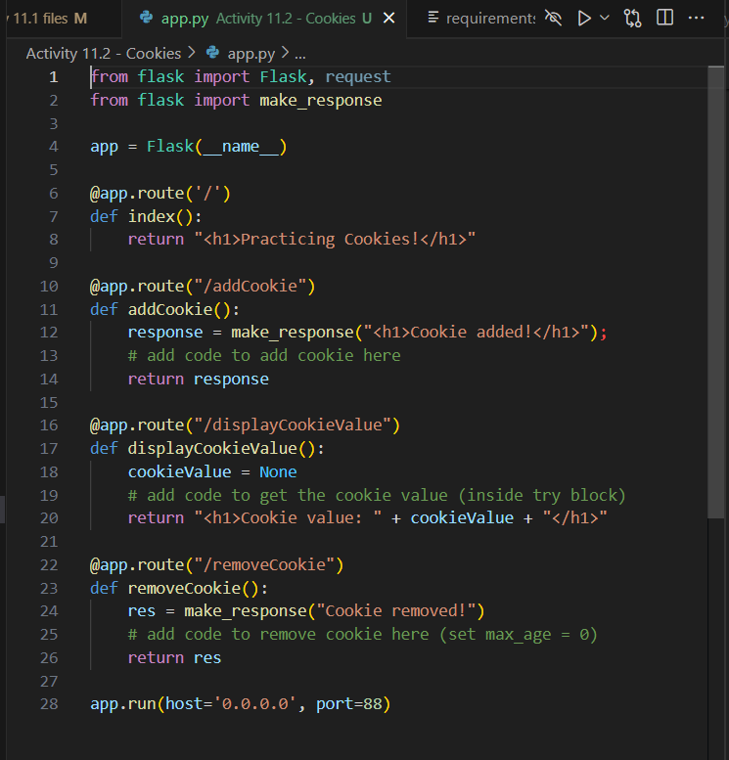

1. A screenshot of the web browser pointing to “http://localhost:88” and displaying “Practicing Cookies!”

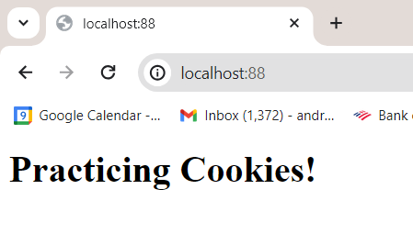

1. A screenshot of the completed *method* addCookie in app.py.

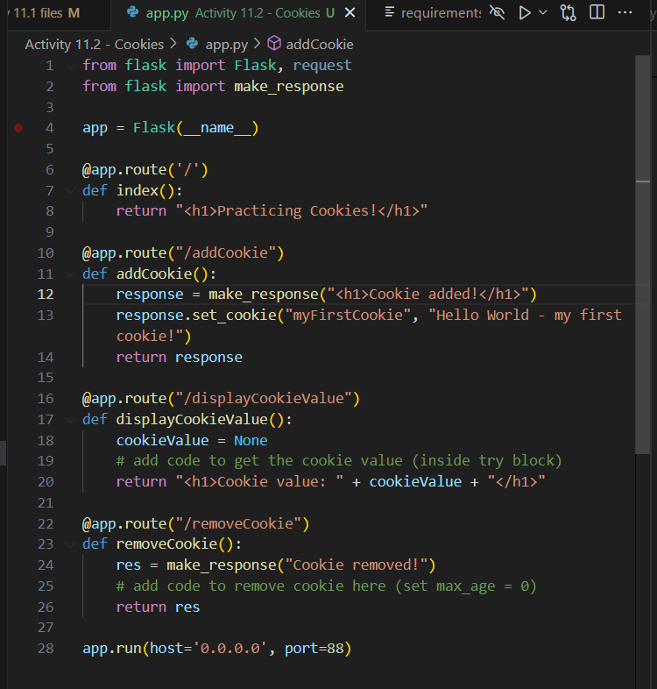

1. A screenshot of the browser pointing to “http://localhost:88/addCookie” and displaying “Cookie added!”

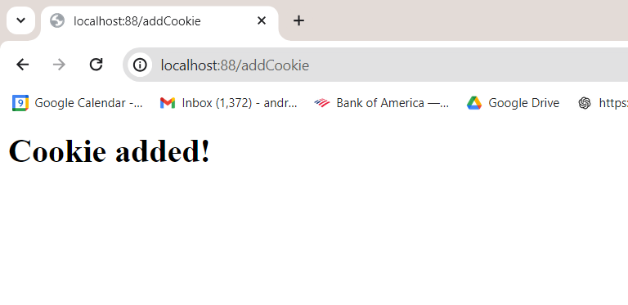

1. A screenshot of the web browser settings displaying the new *cookie* “myFirstCookie”.

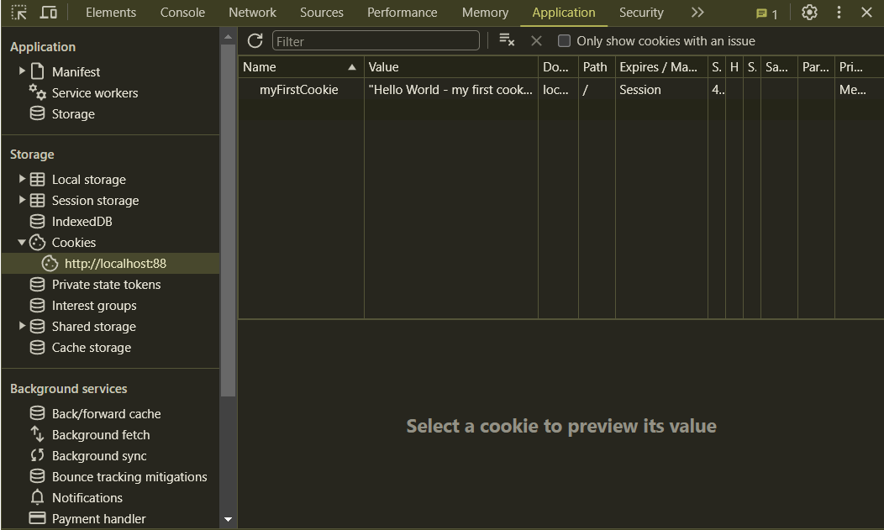

1. A screenshot of the completed *method* displayCookieValue in app.py.

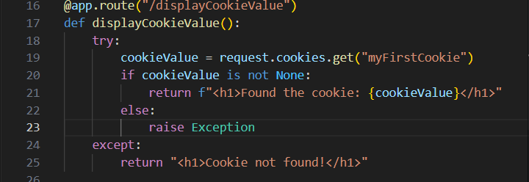

1. A screenshot of the browser pointing to “http://localhost:88/displayCookieValue” and displaying the *cookie* value. Note: ensure you navigate to “http://localhost:88/addCookie” first in order to add the *cookie*.

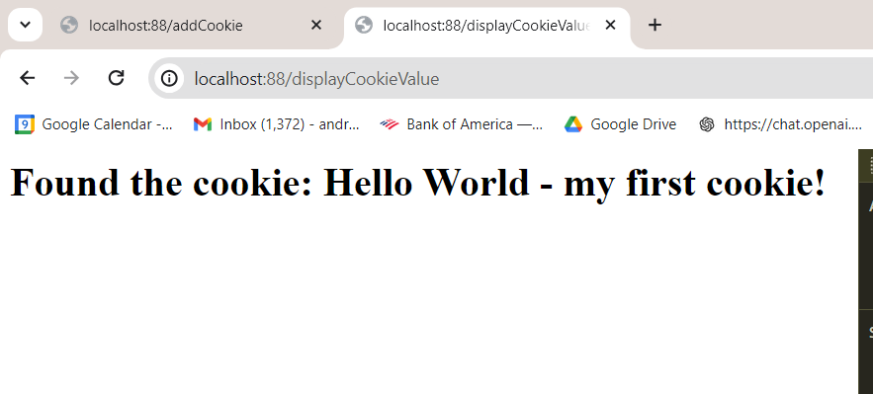

1. After removing the *cookie* “myFirstCookie” from your browser, point your browser to “http://localhost:88/displayCookieValue”. Your browser should display “Cookie not found!”

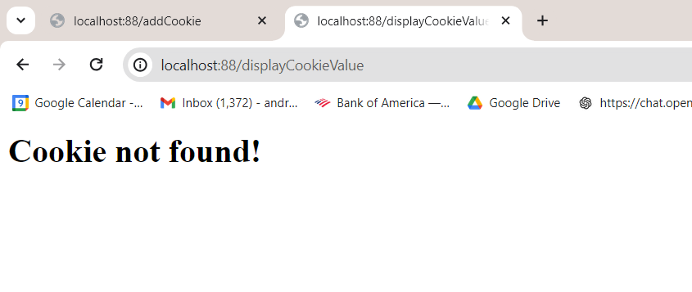

1. A screenshot of the completed *method* for removeCookie in app.py.

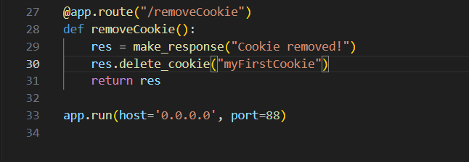

1. A screenshot of your browser settings, after pointing it to “http://localhost:88/removeCookie”, showing that the *cookie* has been removed.

